High-speed Mini-centrifuge—MC15K
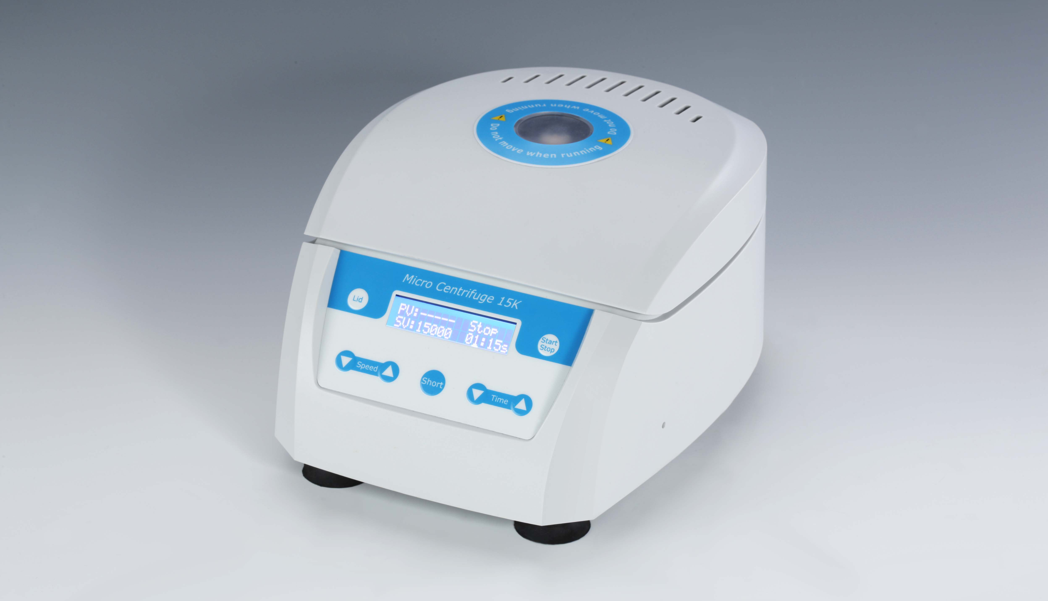
Introduction
The High-speed Mini-centrifuge is a compact centrifuge capable of achieving centrifugal speeds up to 15000rpm, that is approximately 15080g. It is used for extracting RNA/DNA samples, sedimentation of biological components, biochemical and chemical analysis of micro samples. Automatic imbalance switch-off and locking of lid provide safe operation. The rotor accepts 1.5 to 2.0ml tubes directly, as well as 0.5ml and 0.2ml tubes with optional adapters.

Features:
- LCD provides a clear indication of time and rpm or RCF.
- RPM/RCF setting as required.
- The rotor is made of nylon material, with corrosion resistance, minimizes the temperature increases during longer run at high speed.
- Accelerates and decelerates in just 14seconds.
- Safety operation: rotor imbalance diagnostic; automatic stop.
- Motor overheating protection function.
- A separate momentary short button permits instant spin downs.
- Low sample heating (only 5°C after 30min, at max. speed).
- A brushless motor provides noiseless performance and long service life.

Parameters
Model | MC15K
Capacity | 12x1.5/2.0ml centrifuge tubes
Speed range | 500~15000rpm
RCF range | 16~15080g
Timing range | 15sec~99min59sec/∞
Acceleration | 14sec(0~15000rpm)
Deceleration | 14sec(15000~1000rpm)
Rotor imbalance diagnostic | Yes
Motor overheating protection function | Yes
Power | 120W
Voltage | DC24V/5A
Dimension(mm) | 255x194x140mm
Weight | 2.3kg

